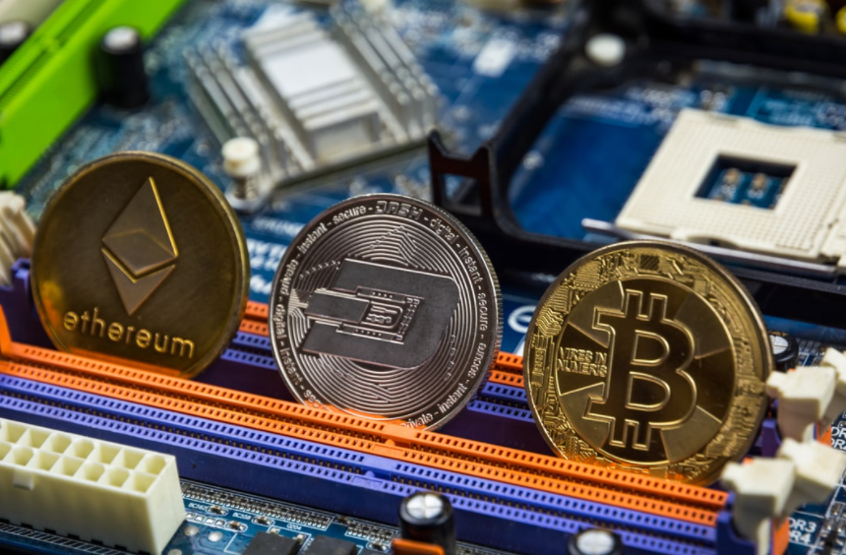

White Paper #1: Understanding Cryptocurrencies:
The Future of Crypto Money

Sunil Erevelles, PhD

This white paper is written solely for educational purposes. It is not meant to be used for investment purposes. Please do not quote from this paper without written permission from the author.

Executive Summary: We believe that a substantial share of the future of money is in crypto money. This percentage will continue to grow exponentially in the near- future and become an essential part of the global marketplace in the longer-term future. However, there will be different types of crypto money. They will ubiquitously be used in trade, risk-hedging and lending.

The History of Money
Before money was invented, there was the ledger. Early human beings traded or bartered what they did best with others. For example, if a cave society family had more food than they could consume, they bartered their surplus with another family that had more

The only thing today that distinguishes paper money, such as the US Dollar, from any other piece of paper is trust.

Money Today
We believe that today’s money system is beyond antiquated. Paper currencies, credit cards, and money transfer models, such as cheques, ACH, wire, have numerous weaknesses and, in many cases, potentially fatal flaws. Major weaknesses in trust, security, transparency, privacy and mediation exist.

The Future of Money

I. Types of Crypto Money
Risk-hedging Crypto Money (Bitcoin)

Trade-focused Crypto Money (Cardano (ADA), Ether)
Entertainment-focused (Atari (ATRI))

Lending-focused Crypto Money (Algorand (ALGO)

Government-Backed Digital Money

Currency-Backed Digital Money (Tether, True USD)

Currency-Pegged Digital Money (USD Coin)

II. The Crypto Money Ecosystem

- Diversified Crypto Money Institutions:
- Galaxy Digital Holdings (BRPHF)
- Ethereum

- Crypto Money Technology:
- Canaan (CAN)

- Crypto Money Exchanges:
- Coinbase (COIN)

